**Lab1**

**Exercise 1: nslookup**

**1. Which is the IP address of the website www.koala.com.au? In your opinion, what is the reason of having several IP addresses as an output?**

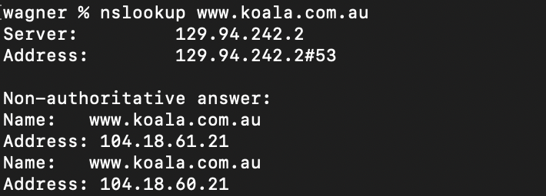

The IP address of the website [www.koala.com.au](http://www.koala.com.au) is 104.18.60.21 and 104.18.61.21. As for why there are several IP addresses outputs, this is to achieve load balancing, which aims to optimize resource use, maximize [throughput](https://en.wikipedia.org/wiki/Throughput), minimize response time, and avoid overload of any single resource.

**2. Find out the name of the IP address 127.0.0.1. What is special about this IP address?**

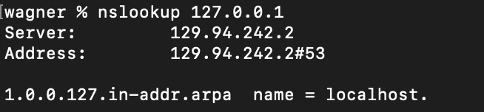

This is so-call Loopback Address, which is the IP address of localhost.

#### Exercise 2: Use ping to test host reachability

**Are the following hosts reachable from your machine by using ping:**

* [www.unsw.edu.au](http://www.unsw.edu.au/)
* [www.getfittest.com.au](http://www.getfittest.com.au/)
* [www.mit.edu](http://www.mit.edu/)
* [www.intel.com.au](http://www.intel.com.au/)
* [www.tpg.com.au](http://www.tpg.com.au/)
* [www.hola.hp](http://www.hola.hp/)
* [www.amazon.com](http://www.amazon.com/)
* [www.tsinghua.edu.cn](http://www.tsinghua.edu.cn/)
* [www.kremlin.ru](http://www.kremlin.ru/)
* 8.8.8.8

**If you observe that some hosts are not reachable, then can you explain why? Check if the addresses unreachable by the ping command are reachable from the Web browser.**

[www.unsw.edu.au](http://www.unsw.edu.au/) reachable

[www.getfittest.com.au](http://www.getfittest.com.au/) unreachable (the host not exist)

[www.mit.edu](http://www.mit.edu/) reachable

[www.intel.com.au](http://www.intel.com.au/) reachable

[www.tpg.com.au](http://www.tpg.com.au/) reachable

[www.hola.hp](http://www.hola.hp/) unreachable (the host not exist)

[www.amazon.com](http://www.amazon.com/) reachable

[www.tsinghua.edu.cn](http://www.tsinghua.edu.cn/) reachable

[www.kremlin.ru](http://www.kremlin.ru/)

Unreachable. The output is time out but it is reachable from the web browser. This is probably because the ping command sends data using the ICMP protocol. ICMP response is disabled or ICMP filtering is enabled on the server

8.8.8.8 reachable

#### Exercise 3: Use traceroute to understand network topology

**1. Run traceroute on your machine to**[www.columbia.edu](http://www.columbia.edu/)**. How many routers are there between your workstation and**[www.columbia.edu](http://www.columbia.edu/)**? How many routers along the path are part of the UNSW network? Between which two routers do packets cross the Pacific Ocean? Hint: compare the round trip times from your machine to the routers using ping.**

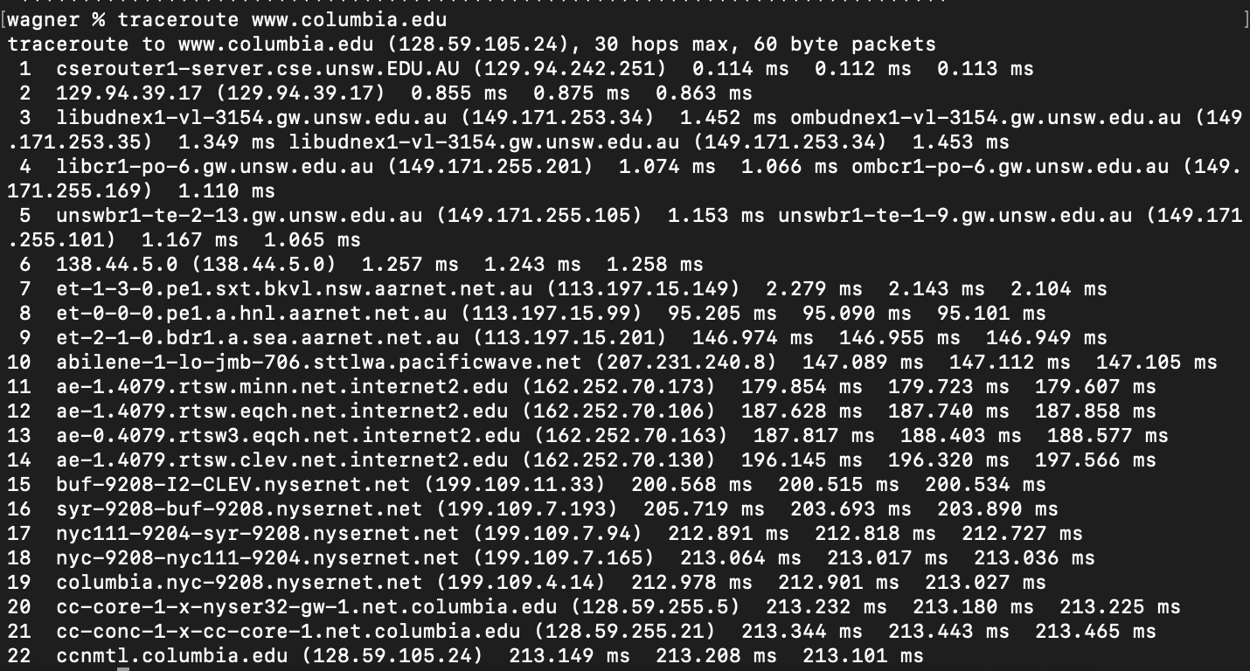

(1) There are 21 routers between my working station and the sever of [www.columbia.edu](http://www.columbia.edu/). (the last one is the destination router)

(2) There are 5 routers that are part of UNSW network.

(3) the 7th (162.252.70.173) router travel across the Pacific Ocean

**2. Run traceroute from your machine to the following destinations: (i)**[www.ucla.edu](http://www.ucla.edu/)**(ii)**[www.u-tokyo.ac.jp](http://www.u-tokyo.ac.jp/)**and (iii)**[www.lancaster.ac.uk](http://www.lancaster.ac.uk/)**. At which router do the paths from your machine to these three destinations diverge? Find out further details about this router. (HINT: You can find out more about a router by running the Whois command: Whois router-IP-address). Is the number of hops on each path proportional the physical distance? HINT: You can find out the geographical location of a server using the following tool -**<http://www.yougetsignal.com/tools/network-location/>

the output as follows:

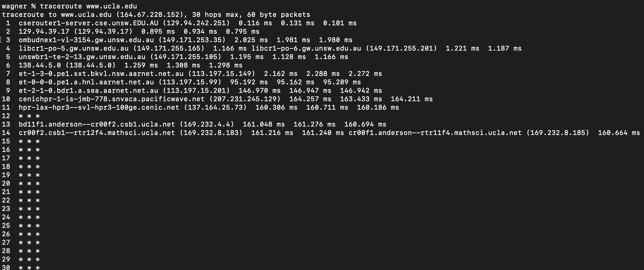

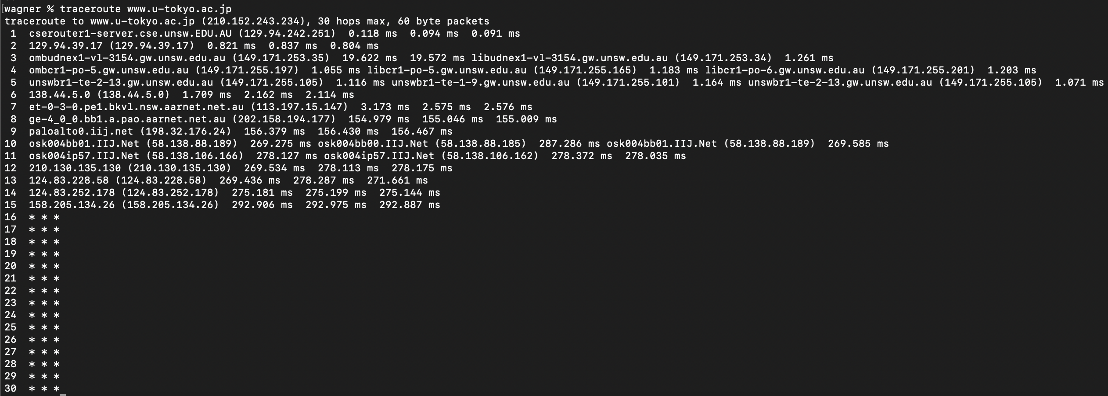

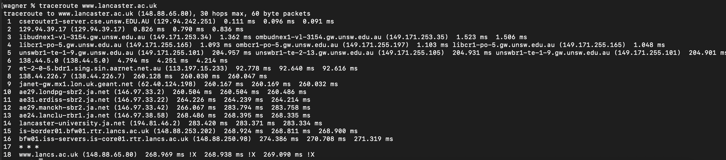

1. The three paths diverge at the 6th router (138.44.5.0). Using whois command to find more detail:

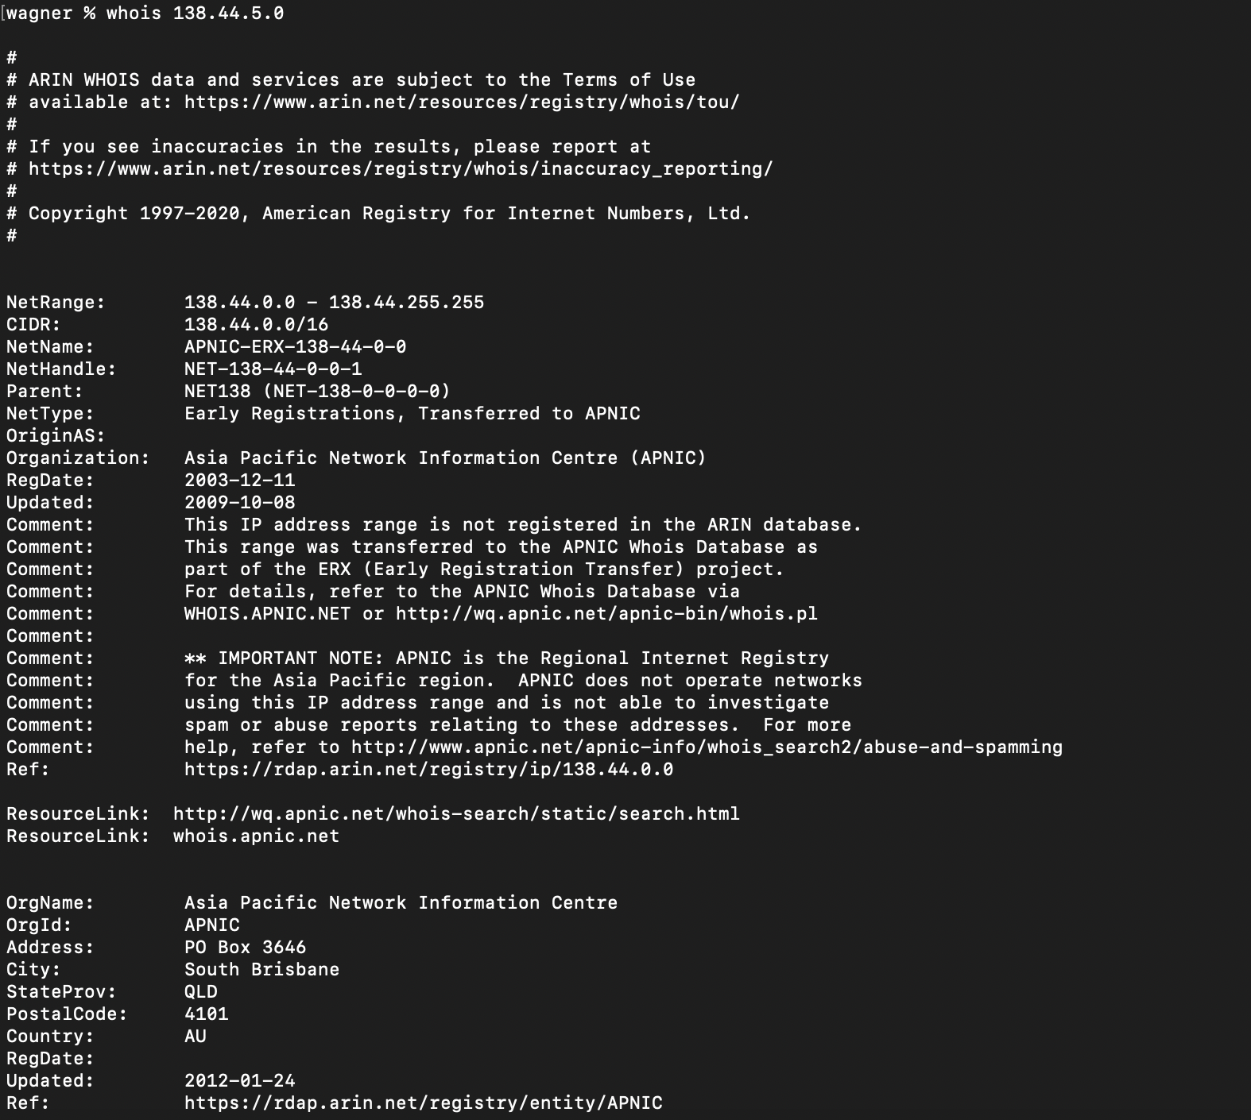

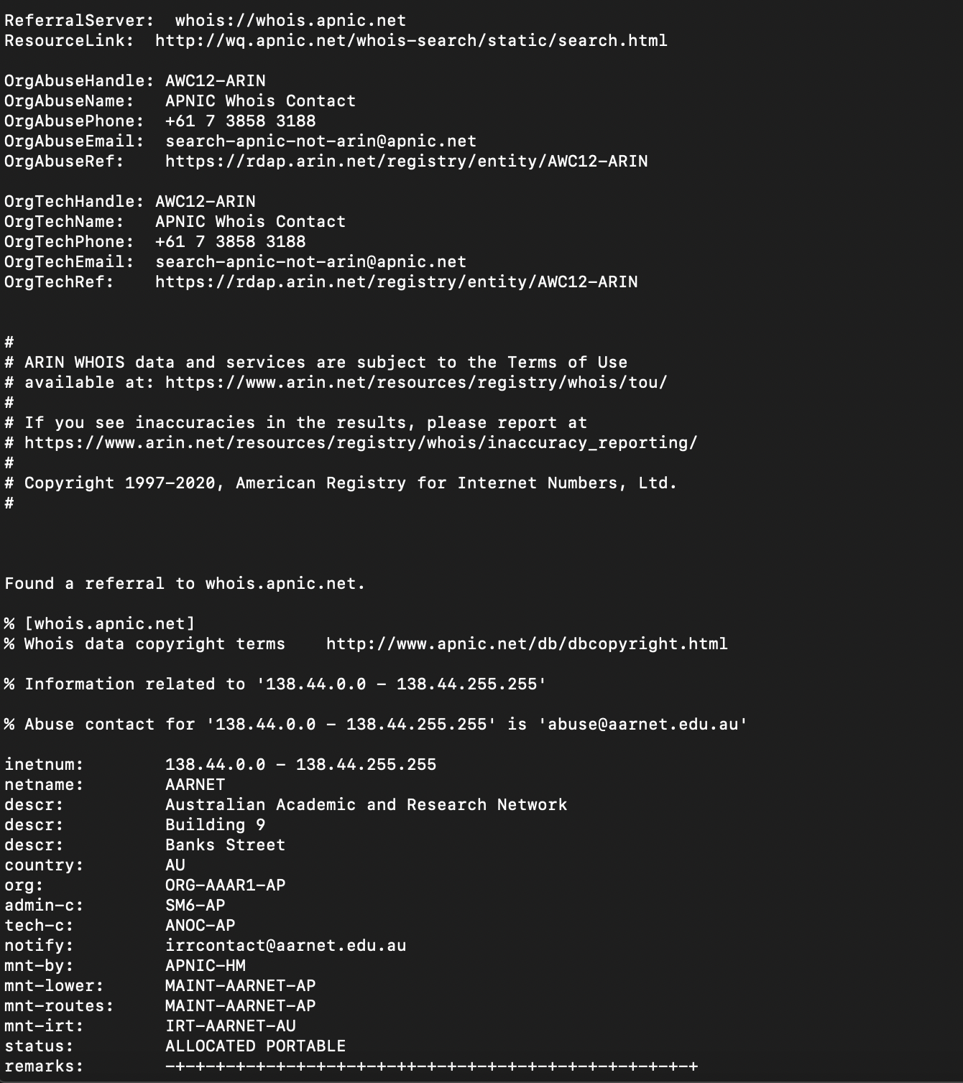

2. The number of hops can only depict the number of routers on a path, which is not related to the physical distance. For example, a hop may travel the whole Pacific Ocean, while there may be multiple routers passed by when I visit a IP address on Melbourne from Sydney.

**3. Several servers distributed around the world provide a web interface from which you can perform a traceroute to any other host in the Internet. Here are two examples: (i)**[**http://www.speedtest.com.sg/tr.php**](http://www.speedtest.com.sg/tr.php)**and (ii)**[**https://www.telstra.net/cgi-bin/trace**](https://www.telstra.net/cgi-bin/trace)**. Run traceroute from both these servers towards your machine and in the reverse direction (i.e. From your machine to these servers). You may also try other traceroute servers from the list at**[**www.traceroute.org**](http://www.traceroute.org/)**. What are the IP addresses of the two servers that you have chosen. Does the reverse path go through the same routers as the forward path? If you observe common routers between the forward and the reverse path, do you also observe the same IP addresses? Why or why not?**

To do this, using the ifconfig command to get my IP address: (129.94.8.97)

Then get a forward path to these two server:

(1) [**http://www.speedtest.com.sg/tr.php**](http://www.speedtest.com.sg/tr.php )

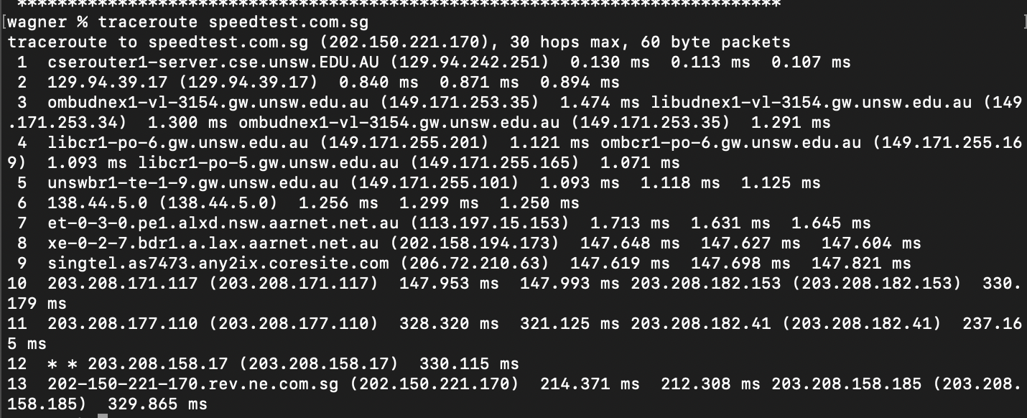

(2)[**https://www.telstra.net/cgi-bin/trace**](https://www.telstra.net/cgi-bin/trace )

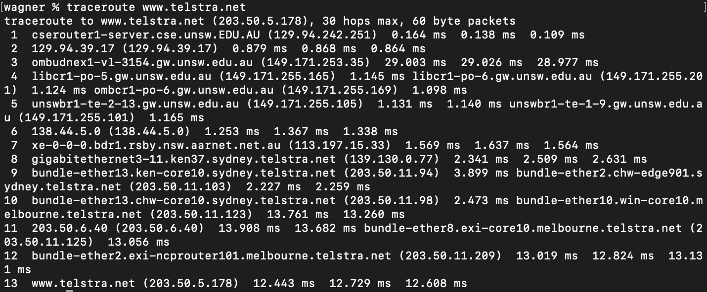

Then the reverse path:

(1)[**http://www.speedtest.com.sg/tr.php**](http://www.speedtest.com.sg/tr.php )

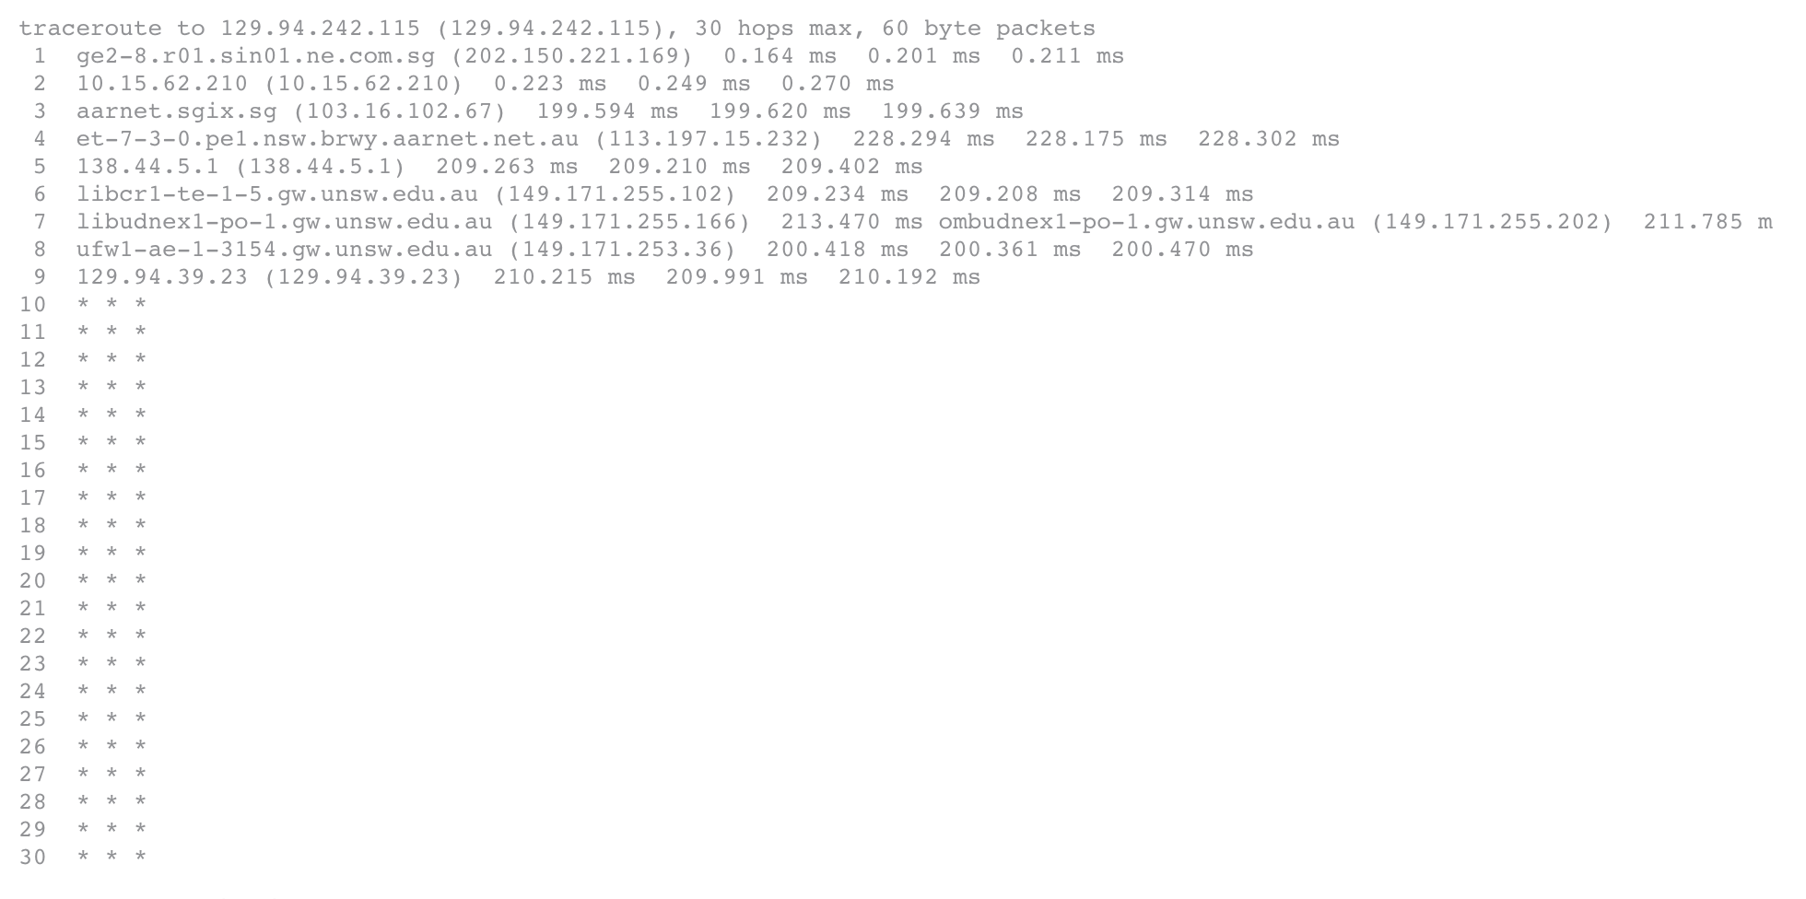

(2) [**https://www.telstra.net/cgi-bin/trace**](https://www.telstra.net/cgi-bin/trace )

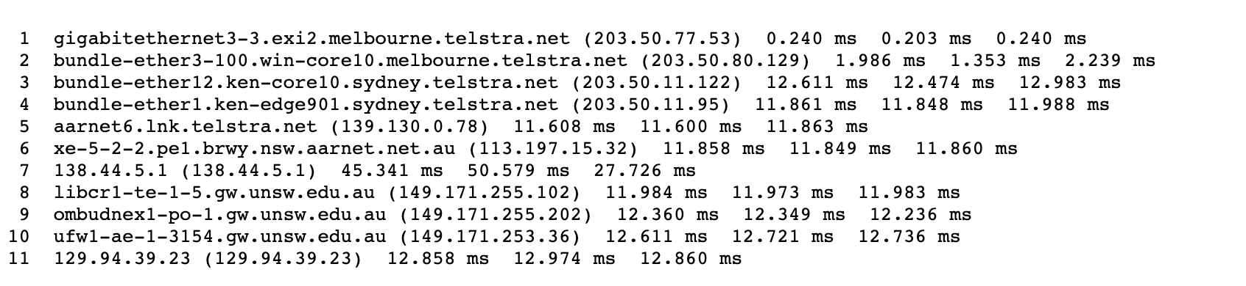

By observation, I find that the reverse path may not go through the same routers as the forward path. Because a same website server may have multiple IP addresses. To maintain the load balance, a different IP address may be assigned on the reverse path even though it is the same router. Also, to minimise latency, packet may be transmitted to different router on the way

**Exercise 4: Use ping to gain insights into network performance**

Chosen location and the direct distance:

(i) [www.uq.edu.au](http://www.uq.edu.au) distance: 734.3 km

(ii) [www.upm.edu.my](http://www.upm.edu.my) distance: 6606.5 km

(iii) [www.tu-berlin.de](http://www.tu-berlin.de) distance: 16104.8 km

**1. For each of these locations ﬁnd the (approximate) physical distance from UNSW using Google Maps and compute the shortest possible time T for a packet to reach that location from UNSW. You should assume that the packet moves (i.e. propagates) at the speed of light, 3 × 108 m/s. Note that the shortest possible time will simply be the distance divided by the propagation speed. Plot a graph where the x-axis represents the distance to each city (i.e. Brisbane, Manila and Berlin), and the y-axis represents the ratio between the minimum delay (i.e. RTT) as measured by the ping program (select the values for 50 byte packets) and the shortest possible time T to reach that city from UNSW. (Note that the y-values are no smaller than 2 since it takes at least 2*T time for any packet to reach the destination from UNSW and get back). Can you think of at least two reasons why the y-axis values that you plot are greater than 2?**

**The result of script file execution can be found in the attached support file(.pdf , .txt)**

**computing the shortest possible time:**

ti = (734.3 × 103) / (3 × 108 ) = 0.00244s = 2.44 ms

tii = (6606.5 × 103) / (3 × 108) = 0.02202s = 22.02 ms

tiii = (16104.8 × 103) / (3 × 108) = 0.05368s = 53.68 ms

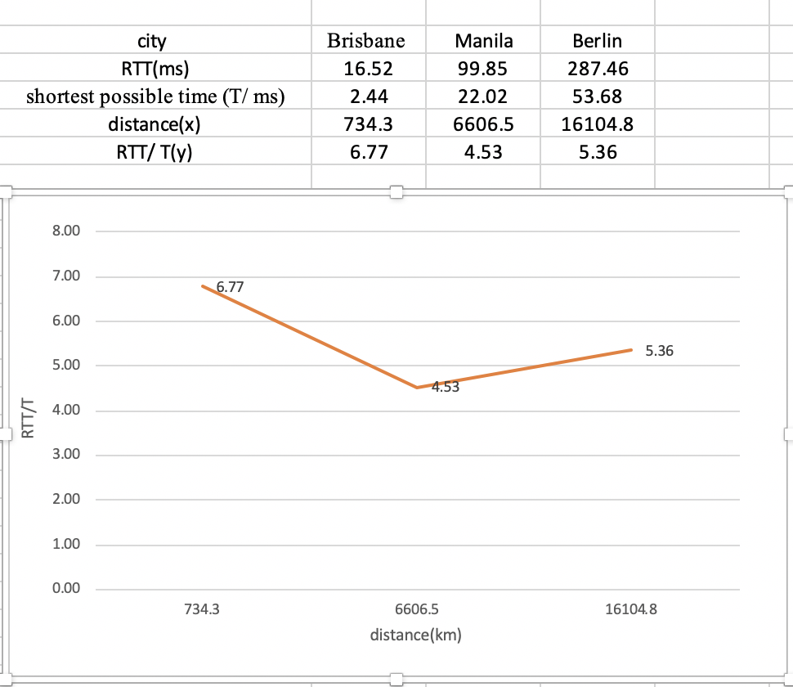

Here is the plotted picture using Excel. There are a lot of reasons that the ratio greater than 2:

(1) The path is usually not straight. The actual distance is highly greater than ideal situations.

(2) The propagation rate may cannot reach 3 × 108 m/s.

(3) This algorithm overlooks the impact of transmission delay, queueing delay and the processing delay.

**2. Is the delay to the destinations constant or does it vary over time? Explain why.**

yes, because the status of routers on a path is usually consistently changing. Sometimes, there may be congestions occurs or server shut down. Even the path (the routers on the path) may vary each time we send a packet. All of these issue would influence the delay.

**3. Explore where the website for**[**www.epfl.ch**](http://www.epfl.ch/)**is hosted. Is it in Switzerland?**

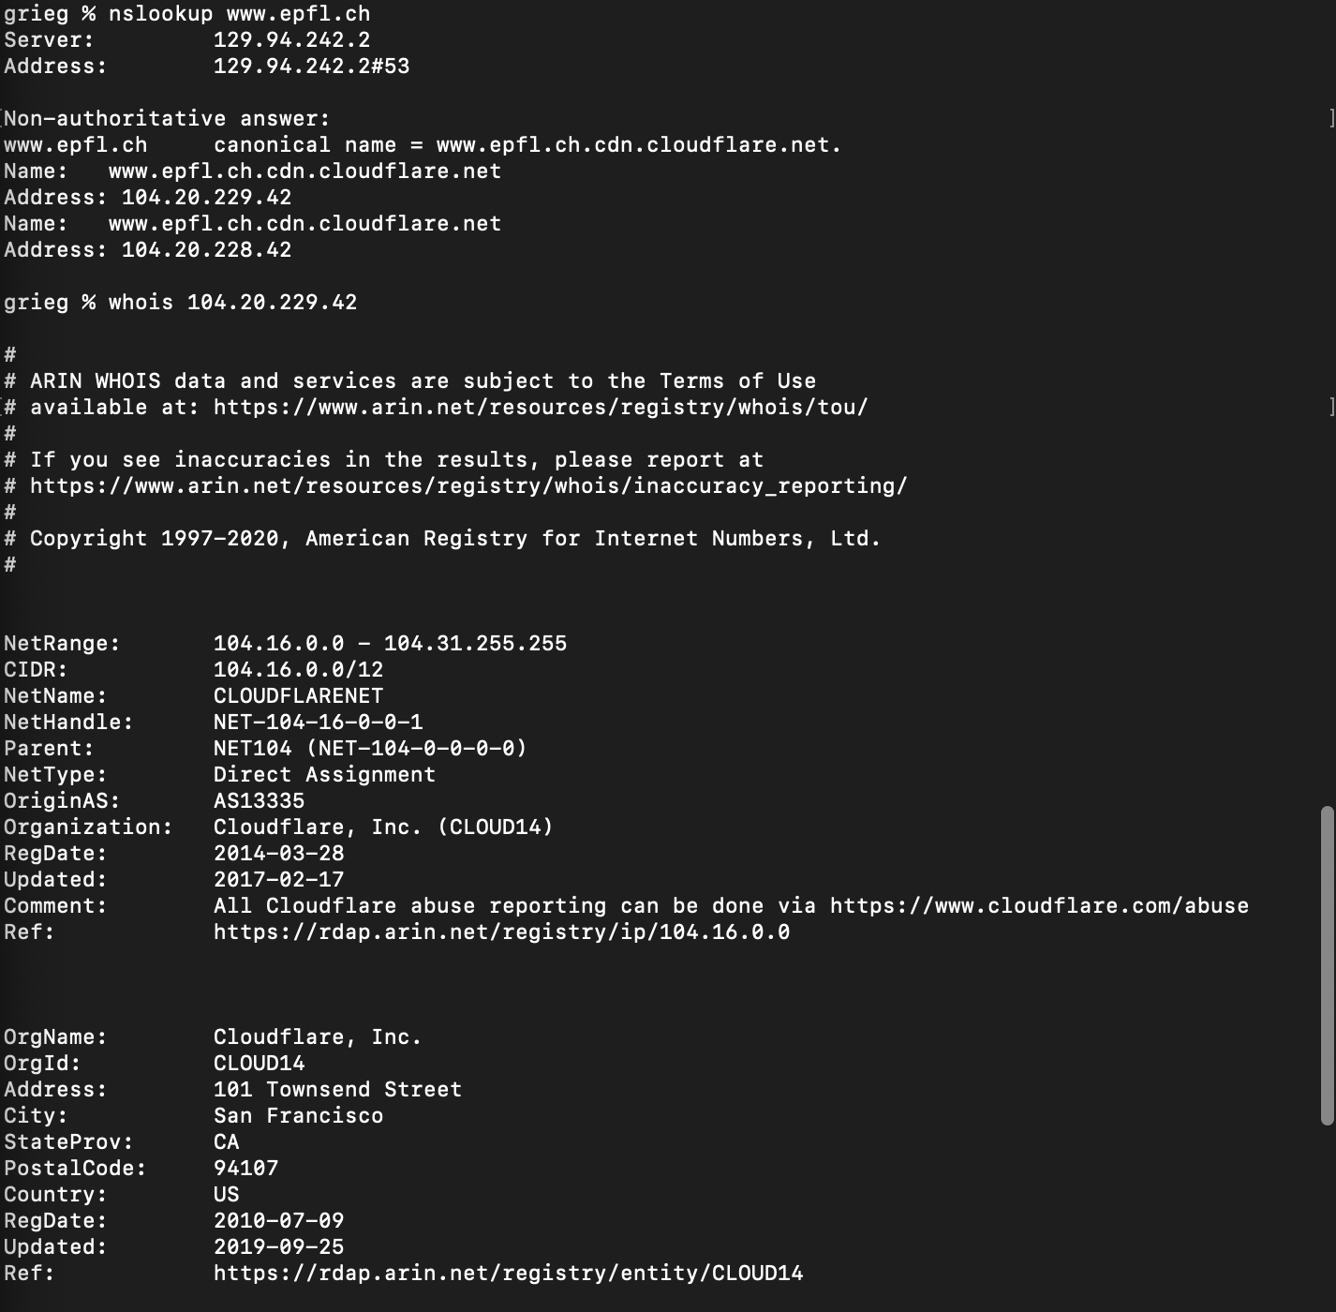

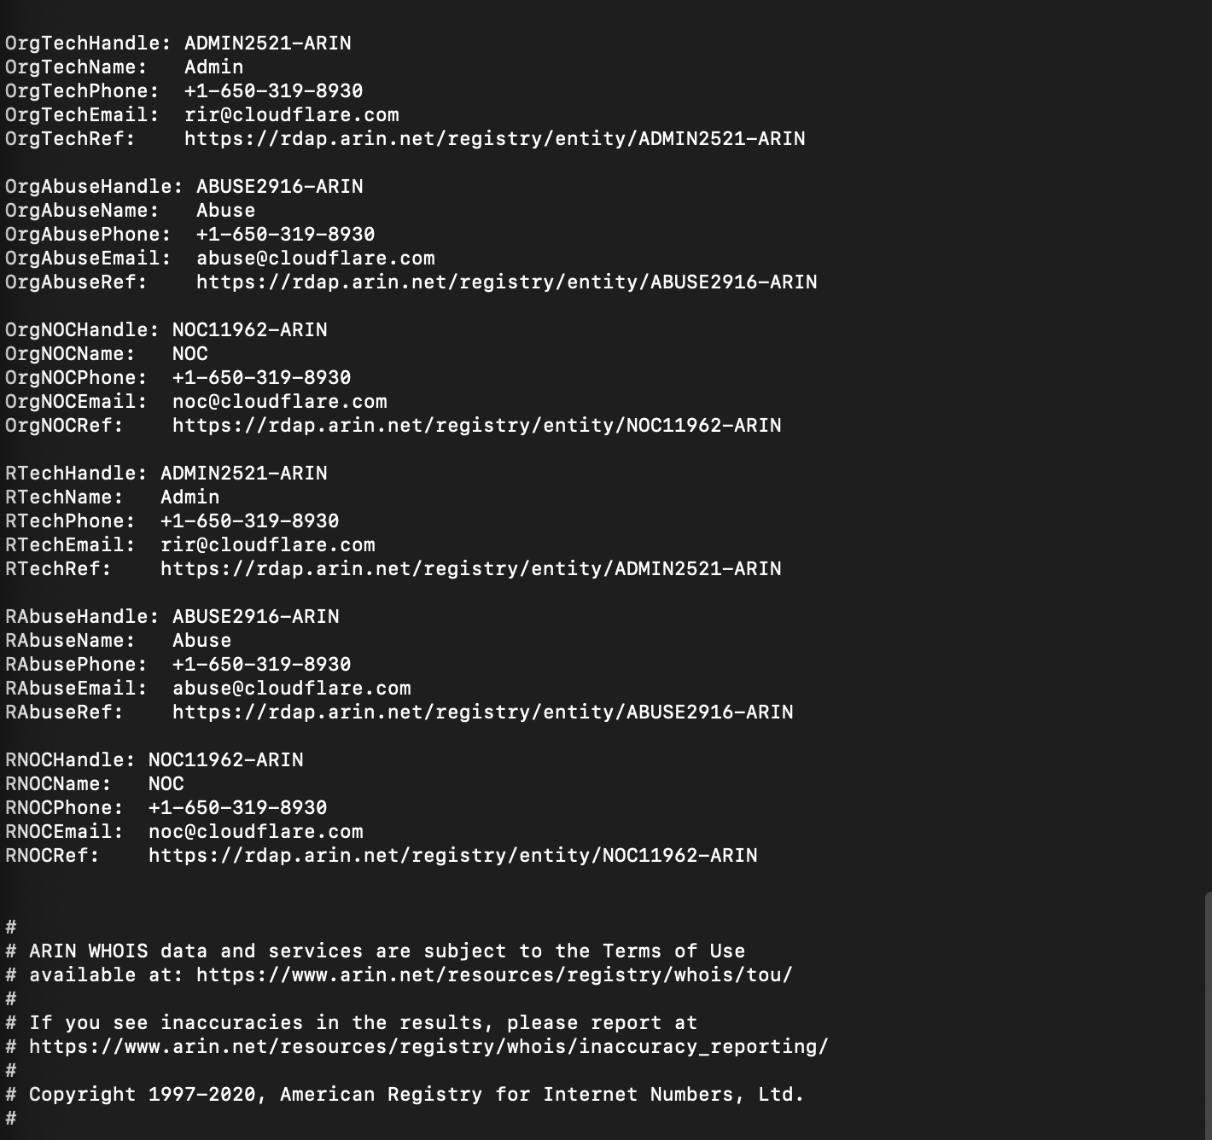

No, the server located in San Francisco

**4. The measured delay (i.e., the delay you can see in the graphs) is composed of propagation delay, transmission delay, processing delay and queuing delay. Which of these delays depend on the packet size and which do not?**

Only the transmission delay and processing delay depends on the packet. Propagation delay, and queueing delay depend on other factors. The queueing delay depends on the congestion level of routers and the propagation delay depends on the propagation rate on physical links and distance.